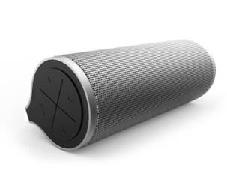

Lenovo 500 2.0 Bluetooth Speaker
Driver Spec | : | 2*5W
Wireless Solution | : | Bluetooth 4.0 & NFC
Battery | : | USDB/ 1800Mah/ 6hrs
Weight | : | 350g
Dimensions | : | 180mm x 94mm x 58mm
Colour | : | Platinum
Connectors | : | Micro USB, microSD card
Price | : | Starting price from RM399

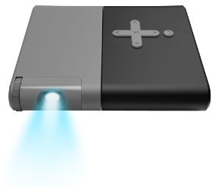

Lenovo Pocket Projector
OS | : | Compatible with Android™ Jelly Bean (4.3) and above, Windows 8.1, and iOS devices equipped with Miracast or DLNA
Aspect Ratio | : | 16:10, 4:3
Display/Resolution | : | Up to 110” (854x480) display
Brightness | : | 50 lumens
Storage | : | MicroSD card with up to 32GB external storage
Sound | : | 2 x speakers, 3.5mm audio jack
Wi-Fi | : | DNLA and Miracast capability
Sensors | : | G-sensor
Battery | : | Up to 2.5 hours of battery life; up to 20,000 hours of LED lamp life
Weight | : | 170g
Dimensions | : | 104mm x 25mm x 100 mm
Colour | : | Platinum
Connectors | : | Micro USB, microSD card
Price | : | TBA. Available in December 2015 / January 2016

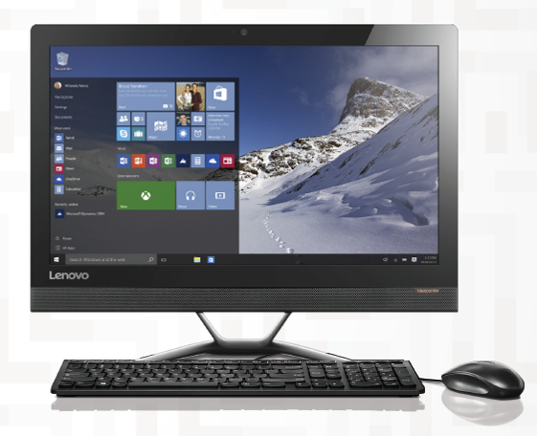

Lenovo ideacentre ™ All-In-One 300
Processor | : | Up to 6th Generation Intel® Core™ i5-6200U Processor
OS | : | Windows 10 Home
Graphics | : | Up to NVIDIA® GeForce GT 920A 2GB VRAM
Memory | : | Up to 16GB DDR4
Display | : | 23.8” FHD (1920x1080), 10-point multitouch (Frameless LED Backlit LCD)
Storage | : | Up to 2TB HDD 7200rpm
Webcam | : | 1080p
Audio | : | Stereo Speakers 3W
Dimensions | : | 559.5mm x 53.6mm x 461.4mm
Weight | : | 8.46kg
Price | : | Starting price from RM2,699

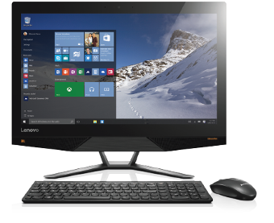

Lenovo ideacentre ™ All-In-One 700 (24-inch)
Processor | : | Up to 6th Generation Intel® Core™ i7-6700 Processor
OS | : | Windows 10 Home
Graphics | : | NVIDIA® GeForce GTX 950A 2GB VRAM
Memory | : | 16GB DDR4
Display | : | 23.8” FHD (1920x1080), 10-point multitouch (Frameless LED Backlit LCD)
Storage | : | Up to 2TB HDD 7200rpm
Webcam | : | Intel Realsense™ 3D Camera (optional)
Audio | : | JBL® Stereo Speakers 2x3W
Dimensions | : | 578.6mm x 466.1mm x 209.7mm
Weight | : | 8.46kg
Price | : | RM3,699 (inclusive of GST)

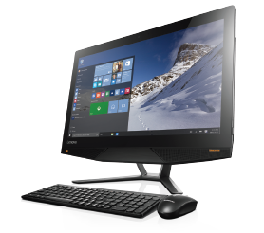

Lenovo ideacentre ™ All-In-One 700 (27-inch)
Processor | : | 6th Generation Intel® Core™ i7-6700 Processor
OS | : | Windows 10 Home
Graphics | : | NVIDIA® GeForce GTX 950A 2GB VRAM
Memory | : | 16GB DDR4
Display | : | 27” UHD (3840x2160), 10-point multitouch (Frameless LED Backlit LCD)
Storage | : | Up to 2TB HDD 7200rpm
Webcam | : | Intel Realsense™ 3D Camera
Audio | : | JBL® Stereo Speakers 2x3W
Dimensions | : | 650.9mm x 501.9mm x 223.6mm
Weight | : | 10.6kg
Price | : | Starting price from RM6,999

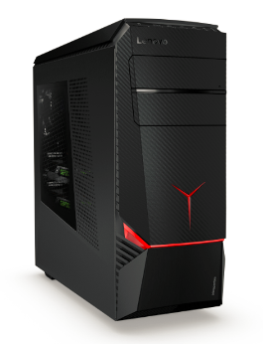

Lenovo ideacentre™ Y900
Processor | : | 6th Generation Intel® Quad-Core i7 6700K Processor
OS | : | Windows 10 Home
Graphics | : | Up to Intel® NVIDIA® GeForce® GTX 980 4 GB
Memory | : | Up to 64 GB (4 DIMM Slots) DDR4
Storage | : | 4 x 3.5" or 2.5" Compatible Hard Drive Bays  (4 x tool-free HDD trays)  Up to 256 GB SSD
Dimensions | : | 206.4mm x 503.5mm x 478.9mm
Weight | : | Starting at 15kg
Price | : | Starting price from RM6,999 (including Lenovo Y Gaming Mouse Pad, Y Gaming Precision Mouse, Gaming Mechanical Keyboard)

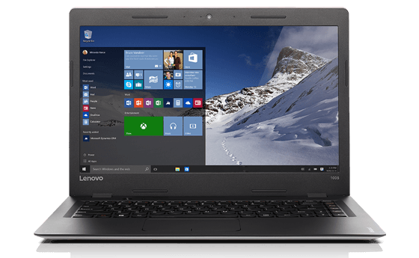

Lenovo ideapad™ 100S (11-inch)
Processor | : | Intel® Quad-Core Atom, Z3735F Processor
OS | : | Windows 10 Home
Graphics | : | Integrated Intel® Graphics
Memory | : | 2GB DDR3L
Storage | : | 32 GB EMMC
Display | : | 11.6 HD GL (Slim)
Audio | : | Stereo Speakers with Dolby® Advanced Audio™ Certification
Battery | : | Up to 7 Hours with standard battery
Weight | : | 1kg
Colour | : | Blue, Silver and Red
Price | : | Starting price from RM799

Lenovo ideapad™ 100S (14-inch)
Processor | : | Intel® Celeron® N3050 Processor
OS | : | Windows 10 Home
Graphics | : | Integrated Intel® Graphics
Memory | : | 4GB
Storage | : | 128GB SSD
Display | : | 14.0 HD GL
Audio | : | Stereo Speakers with Dolby® Advanced Audio™ Certification
Battery | : | Up to 7 Hours with standard battery
Weight | : | 1.5kg
Colour | : | Silver and Red
Price | : | Starting price from RM1,299

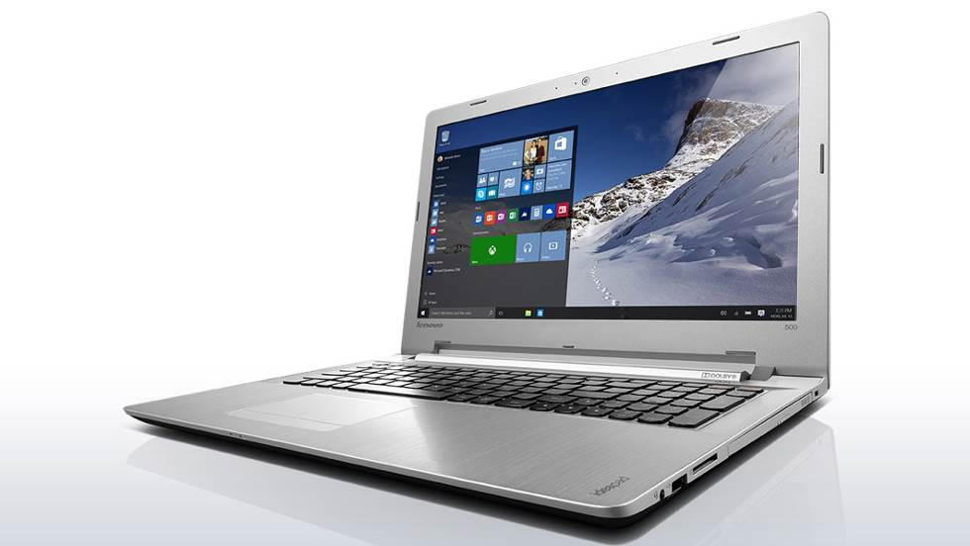

Lenovo ideapad™ 500
Processor | : | 6th Generation Intel® Core™ i7 6500U Processor
OS | : | Windows 10 Home
Graphics | : | - Intel® HD Graphics 520  - AMD Radeon R7 M360, Up to 4GB DDR3
Memory | : | Up to 16 GB DDR3L
Display | : | 15.6 FHD Anti-Glare
Storage | : | 1TB 5400 RPM
Webcam | : | 1MP HD with Single Microphone / Intel® RealSense™ 3D Camera(Optional) (15" only)
Audio | : | JBL® Stereo Speakers(Optional) with Dolby® Advanced Audio™ Certification
Battery | : | 41wh (up to 4 hrs)
Dimensions | : | 384mm x 265mm x 24.6mm
Weight | : | 2.3kg
Price | : | Starting price from RM3,499

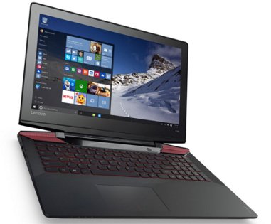

Lenovo Y700 Laptop
Processor | : | 6th Generation Intel® Quad-Core i7- 6700HQ Processor
OS | : | Windows 10 Home
Graphics | : | NVIDIA® GTX 960M 4 GB GDDR5
Memory | : | Up to 16 GB DDR4
Storage | : | Up to 1 TB HDD + 128 GB SSD
Webcam | : | HD 720p, 2 x Internal Digital Array Microphone
Audio | : | 1MP HD with Single Mircophone / Intel ® RealSense™ 3D Camera (optional)
Battery | : | 60 Wh (up to 5hrs)
Keyboard | : | Red LED Backlit with 2 Level Brightness Control
Display | : | 15.6 Frameless FHD IPS (1920 x 1080) Anti-Glare
Dimensions | : | 423mm x 305mm x 27.95mm
Weight | : | 3.5 kg
Price | : | Starting price from RM4,699 (including Lenovo Y Gaming Mouse Pad, Y Gaming Precision Mouse)

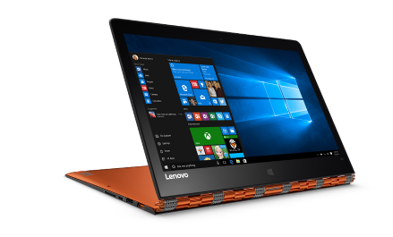

Lenovo YOGA™ 900
Processor | : | 6th Generation Intel® Core™ i7 6500U Processor
OS | : | Windows 10 Home
Graphics | : | Integrated Intel® HD Graphics
Memory | : | Up to 16GB RAM LPDDR3L
Display | : | 13.3" QHD+ (3200 x 1800) IPS 10-point multitouch, 300 nits
Storage | : | Up to 512GB DDR
Webcam | : | 1MP 720p HD CMOS Camera
Audio | : | JBL® Stereo Speakers with Dolby® DS 1.0 Home Theater® Certification
Battery | : | Up to 9 hours local video playback
Dimensions | : | 324mm x 225mm x 14.9mm
Weight | : | 1.29kg
Price | : | TBA. Available in January 2016

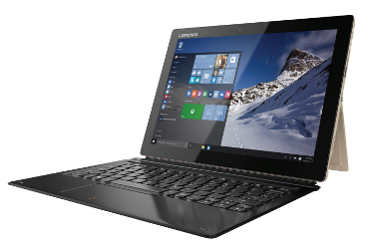

Lenovo MIIX 700
Processor | : | 6th Generation Intel® Core™ m7 Processor
OS | : | Up to Windows 10 Pro
Graphics | : | Integrated Intel® HD
Memory | : | Up to 8 GB LPDDR3L
Display | : | Up to 12" FHD+ (2160 x 1440), 300 nits
Storage | : | Up to 256 GB SSD
Camera | : | Front : 5MP  Rear : 5MP with Auto Focus and Flash / Intel® RealSense™ 3D Camera
Audio | : | Single Stereo Speaker
Battery | : | Up to 9 Hours
Dimensions | : | 292mm x 210mm x 8.95mm
Weight | : | 780g
Price | : | TBA. Available in January 2016

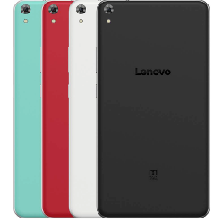

Lenovo PHAB
Processor | : | Qualcomm® MSM 8916, 64-bit, 1.2GHz
OS | : | Android™ 5.1
Memory | : | 1GB
Display | : | 6.98” HD (1280 x 720) IPS 5-point multitouch
Storage | : | 16GB (Internal)  Up to 64GB microSD (Expandable)
Camera | : | 13 MP auto-focus with flash (Rear)  5 MP (Front)
Audio | : | Dolby Atmos®
Battery | : | 4250mAh  Usage Time: Up to 24 hours  Standby Time: Up to 20 days
Dimensions | : | 186mm x 97mm x 8.9mm
Connectivity | : | GPS, Voice Call, 4G LTE, Bluetooth 4.0, Dual band Wifi (2.45GHz 802.11b/g/n + 5GHz 802.11a )
SIM | : | Dual slots: nano & micro SIM
Weight | : | 250g
Colour | : | Tuxedo Black, Polar White, Aqua Blue, Cherry Red
Price | : | RM799 (inclusive of GST)

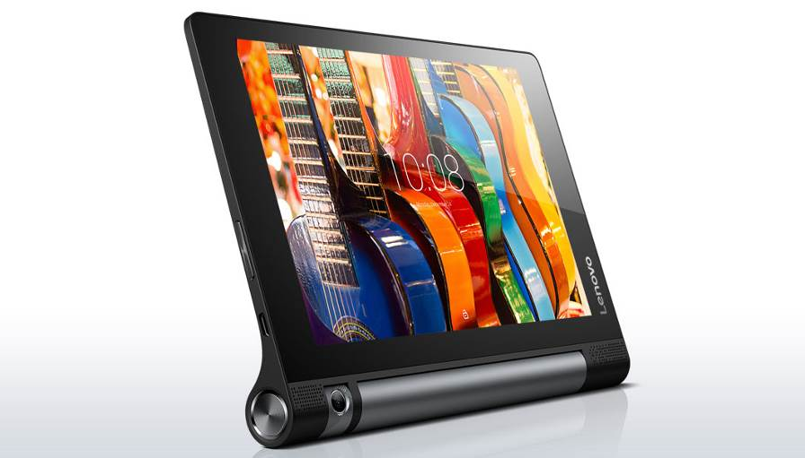

Lenovo YOGA™ TAB 3 (8-inch)
Processor | : | Qualcomm ® MSM8909 32-bit 1.3GHz Quad-Core
OS | : | Android™ 5.1
Graphics | : | Integrated Intel® HD Graphics
Memory | : | 1GB
Display | : | 8" HD (1280 x 800) IPS, 10-point multitouch
Storage | : | 16GB (Internal)  Up to 128GB microSD (Expandable)
Camera | : | 8MP Rotatable Auto Focus
Audio | : | Dual front-facing Stereo Dolby ATMOS™ speakers
Battery | : | Up to 20 hours
Dimensions | : | 210mm x 146mm x 7-7.3mm
Connectivity | : | GPS, Voice Call, 4G LTE, Bluetooth 4.0
SIM | : | 1 x Micro SIM card slot
Weight | : | 472g
Colour | : | Slate Black
Price | : | Starting price from RM949

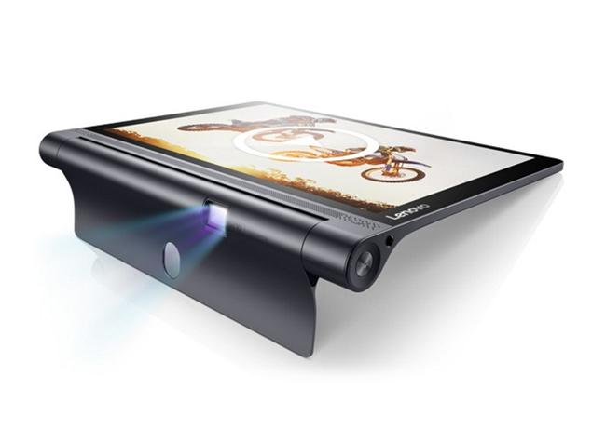

Lenovo YOGA™ TAB 3 Pro (10-inch)
Processor | : | Intel® Atom™ x 5-Z8500 Processor
OS | : | Android™ 5.1
Memory | : | 2GB
Display | : | 10.1" QHD (2600 x 1440) IPS, 10-point multitouch
Storage | : | 32GB (Internal)  Supporting microSD card up to 128GB (Expandable)
Camera | : | 5MP fixed-focus (Front)  13MP auto-focus (Rear)
Built in Projector | : | Casts up to 70” display
Audio | : | 4 Front-facing JBL® Speakers with Dolby® Atmos™
Battery | : | Up to 18 hours
Dimensions | : | 247mm x 4.68mm x 179mm
Connectivity | : | GPS, Voice Call, 4G LTE, Bluetooth 4.0
SIM | : | 1 x Micro SIM card slot
Weight | : | 664g
Colour | : | Puma Black
Price | : | TBA. Available in December 2015

